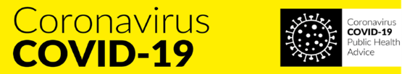
Return to Work Form
Employee Name: ___________________
Date of Form Completion: ________ Expected Return to Work Date: ________
- Do you have any of the following symptoms now or have you had in the past 14 days?
Cough Yes No Fever Yes No
High temperature Yes No Sore throat Yes No
Runny nose Yes No Breathlessness Yes No
Flu like symptoms Yes No

- Have you been diagnosed with suspected Covid-19 infection in the last 14 days?
Yes No
- Have you been diagnosed with confirmed Covid -19 infection in the last 14 days?
Yes No
- Are you a close contact of a person who is a confirmed or suspected case of COVID-19 in the past 14 days (i.e. less than 2m for more than 15 minutes accumulative in 1 day)?
Yes No
- Have you been advised by a doctor to self-isolate at this time?
Yes No
- Have you been advised by a doctor to cocoon at this time?
Yes No
- Please provide details of any other circumstances relating to Covid-19 not included in the above questions that need to be disclosed to allow your safe return to work?
______________________________________________________________________________
Signed : ____________ (Employee) Date: _______
The Return to Work Safely Protocol states that if you have answered ‘yes’ to any of these questions, you are strongly advised to seek and follow medical advice before returning to work.
PLEASE NOTE THAT THE INFORMATION ON THIS FORM WILL BE TREATED IN THE STRICTEST CONFIDENCE IN LINE WITH OUR GDPR POLICY ON SENSITIVE PERSONAL INFORMATION

